FitLike2
User manual

Purpose
FitLike aims at facilitating the coarse analysis of relaxometry data obtained from the Stelar relaxometers. It allows importing raw data files, selecting how to process it at each step of the data processing steps and to fit the dispersion curve with models that can be added together and visualised separately. It also allows saving the data obtained and exporting relevant measurement for further statistical analyses. For further work with relaxometry data, one can also see fiteia (http://fitteia.org/).
FitLike is available on Gihub under the GNU GPL license at https://github.com/ManuIdentiFY/FitLike2.

Basic concepts
FitLike re-uses the concept developed by Stelar for the data handling. Data acquisitions are organised by blocs, which correspond to one acquisition of several data points such as an FID or an echo train. Blocs are grouped by zones, which are used to determine T1 at a given field. Finally, zones are grouped into dispersions, which describe how T1 or R1 vary with the magnetic field.
Note that all the figures provided in by FitLike are in International Units System, as far as possible.

Principles of operation
FitLike is made of three components:
- data storage: it contains all the classes required to store the data generated during use. These may be data blocs, zones or dispersions. These are passive classes, as far as possible.
- data controller: it contains the classes that perform the data processing and conversions. This may be the algorithms that convert blocs into zones, zones into dispersions, or fit the dispersion curves. It also regroups the fit models.
- data viewer: this contains all the code required for the GUI. The viewer classes do not process the data, but only disply them and help handling and controlling the data processing flow.

Relaxometry data processing is usually performed by stages. The first one consists in importing the raw data into blocs and to sort them by type of experiments. Then the blocs are converted into zones by selecting the appropriate algorithm, which depends on the type of acquisition. The zone objects can then be regrouped and processed into dispersion objects, once more by selecting the appropriate algorithm. Finally, the dispersion objects can be analysed by custom-made models that can be build from the GUI.
All the algorithm structures have been designed in such a way that it is easy to create your own processing class with relatively little knowledge of Matlab. Template classes have been written that can be copied and modified into your own algorithm, which should then appear from the GUI. If you write your own code, please consider sharing it via the Github website or email it to the developers to help the community.

Data structure
The data classes are organised as follow:
- DataUnit: parent class at the origin of all the other data classes. It handles the basic operations and defines how the data is stored. For simplicity of coding, any data object stores a 1-dimensional dataset in the fields 'x' and 'y'. The error on 'y' is provided in the field 'dy', and a mask is also stored in the field 'mask' (note that masked points are associated with the value 0). DataUnit objects also have a 'legendTag' field that stores strings to be used for legend in plots. 'legendTag' strings automatically concatenate as the object is being processed.
- Bloc, Zone and Dispersion: each one of these classes refer the the corresponding dataset. They are derived from DataUnit and contain class-specific methods.
- ParamObj: this is the parent class for the handling of parameters from the raw data files. The format of the parameters changes with the version of the EVO console so that different sub-classes are required to handle them correctly (ParamV1 and ParamV2). This also allows importing other types of data files.
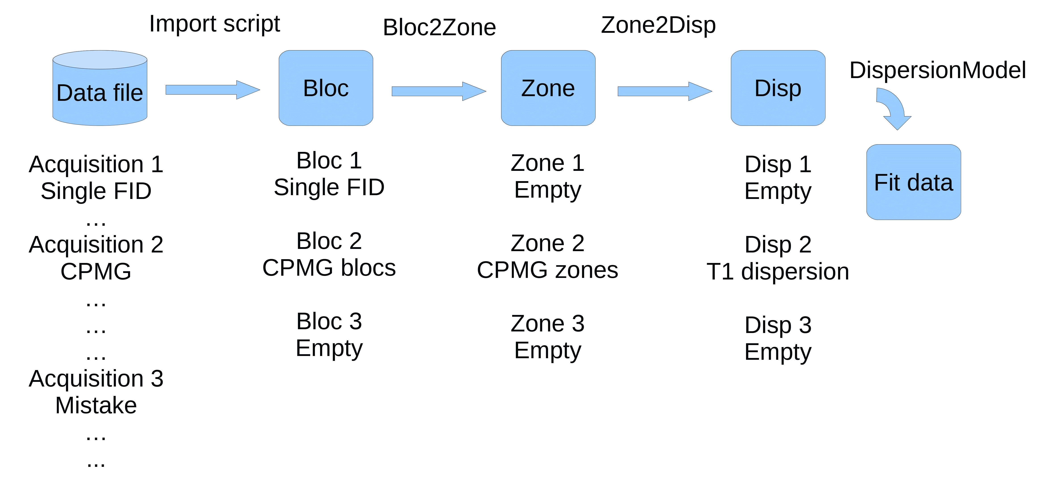

Data controller
This component contains two types of classes: data import and data processing.

Data import
This regroups the import function required to read the stelar data files (or other types of files). It also contains various tools needed to facilitate the import tasks.

Data processing
This regroups all the functions needed to transform objects from one class to another as well as to perform curve fitting operations. It also contains the list of models and dispersion fitting algorithms. The processing of DataUnit object provides an array of DataUnit of the next level. For instance, once can process an array of Bloc objects with a Bloc2Zone algorithm to obtain a new array of Zone objects. The number of objects depends on the algorithm: if the model provided contains two outputs, then there will be twice as many Zone objects as there were Blocs in the input. In such a case it is important to provide a meaningful legend in the processing algorithm so that the Zone objects are labelled in a way that makes sense to the user. For instance, a bi-exponential T1 fit aglorithm may have the field 'legendTag' as {'Long T2 component','Short T2 component'} so that each Bloc object will provide a first Zone object with the 'legendTag' field set to 'Long T2 component' and a second Zone object with the other tag. The data stored in each Zone object can then be determined by the boundaries set to each parameter of the Biexponential model.
The processing algorithms are designed to use arrays of objects to facilitate data processing. Any further development must take care to remain compatible with this.
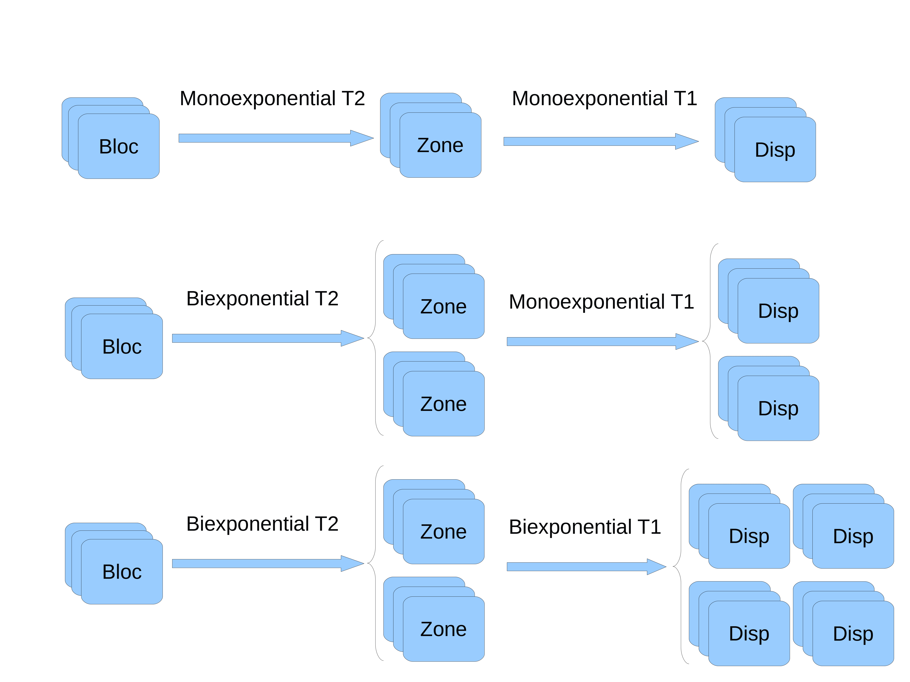

Data viewer
This component contains all the classes required to display the data and to interact with the GUI.

Description of the Matlab objects and function

ParamObj
This class is designed to contain some parameters in a structure (field paramList) and to facilitate some file-dependent operations such as generating time axes.

Data import function
[dataArray, parametersArray] = readsdfvX(filename)
At a low level, importing experimental data is done using the functions readsdfv1 or readsdfv2 depending on the version of the sdf file. These function need the file name of the data file to be openened (from fopen) and return two elements, an array of data and an array of parameter objects. These can then be used to generate an array of custom-made bloc objects.

Example:
[data,param]= readsdfv2('tube16.1_All_P.sdf');
'data' and 'param' are cell arrays with the content of the file selected.

DataUnit
This is the class of object from which are derived all the objects that contain some data, i.e. Bloc, Zone and Disp. It contains the following fields:
x: array of doubles, stores the values used to generate the X-axis of the plot (time, Bevo,...)
y: array of doubles, stores the values used to generate the Y-axis of th plot ('R1','fid',...)
dy: array of doubles, stores the values used to generate the error bars on Y
xLabel: string of characters displayed along with the X axis in TeX format ('Time (s}, ...)
yLabel: string of characters displayed along with the Y axis in TeX format ('R_1 (s^{-1}, ...)
mask: array of booleans to mask the fields above, 1 when the data is retained, 0 when removed
parameter: ParamObj object containing the parameters associated with the data
legendTag: contains a string of characters that is used to label the dataset in the legends.
One Bloc object contains all the blocs generated by one experiment, so that they should have the same pulse sequence. When creating a bloc, the data is organised by array of objects so that batch operations are facilitated by the use of cellfun and arrayfun (see Matlab documentation). Bloc objects can be created from the outputs of the readsdfvX functions quite easily because they accept cells as inputs, in which case they create arrays of objects using each element of the cell arrays provided.
The function makeComplexBloc facilitates the creation of Bloc lists from the outputs of the file readers.

Examples:
blocList = makeComplexBloc(data,param);
blocList is an array of Bloc objects with the same size as 'data' or 'param'.

ProcessDataUnit
Bloc, Zone and Disp objets can be used to generate new data. Zone object are used to make Disp objects, and Blocs are used to make Zone (or Disp, too, is a proper class is defined). These processes can be modified to use different algorithms or parameters, so this process has been encapsulated into an object of type ProcessDataUnit.
ProcessDataUnit objects transform one type of object into another:
Bloc2Zone: takes an array of Blocs as an input and provides an array of Zones
Zone2Disp: same as above, but from Zone to Disp object
Bloc2Bloc: filter class that acts on a Bloc object
etc...
The fields for this objects are as follows:
functionName: string of chars, name of the model as appearing in the figure legend
labelY: string of char, labels to be used to generate the Y-axis labels
labelX: string of char, labels to be used to generate the X-axis labels
Other classes derived from this one have specific fields and methods. For instance, Bloc2Zone objects derive from ProcessDataUnit and have the additional method makeZone, which generate the Zone object from the Bloc object. Zone2Disp objects have the method makeDisp, which does a similar job.
For instance, ProcessAverageAbs is a class that generate Zone objects by using the average of the magnitude data from the Bloc objects,so it derives from Bloc2Zone.

Example:
b2z = ProcessAverageAbs;
zoneList = makeZone(b2z,blocList);

